HOMEWORK1

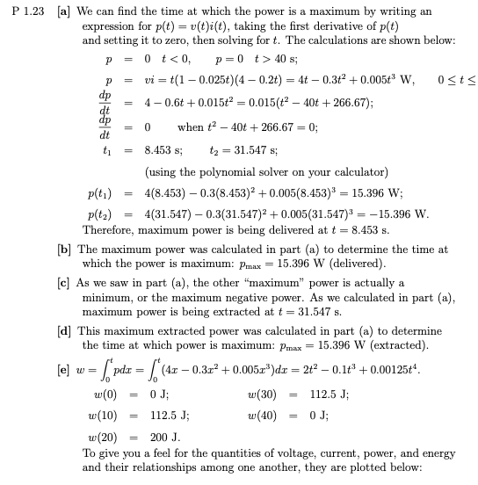

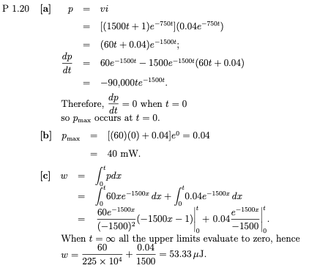

HOMEWORK 2

